STEP 1: Create Resource Group
- Go to Azure Portal → Resource Groups → + Create.
- Enter:
  - Resource Group: <studentname-rg>
  - Region: East US (or your preferred region)
- Click Review + Create → Create.
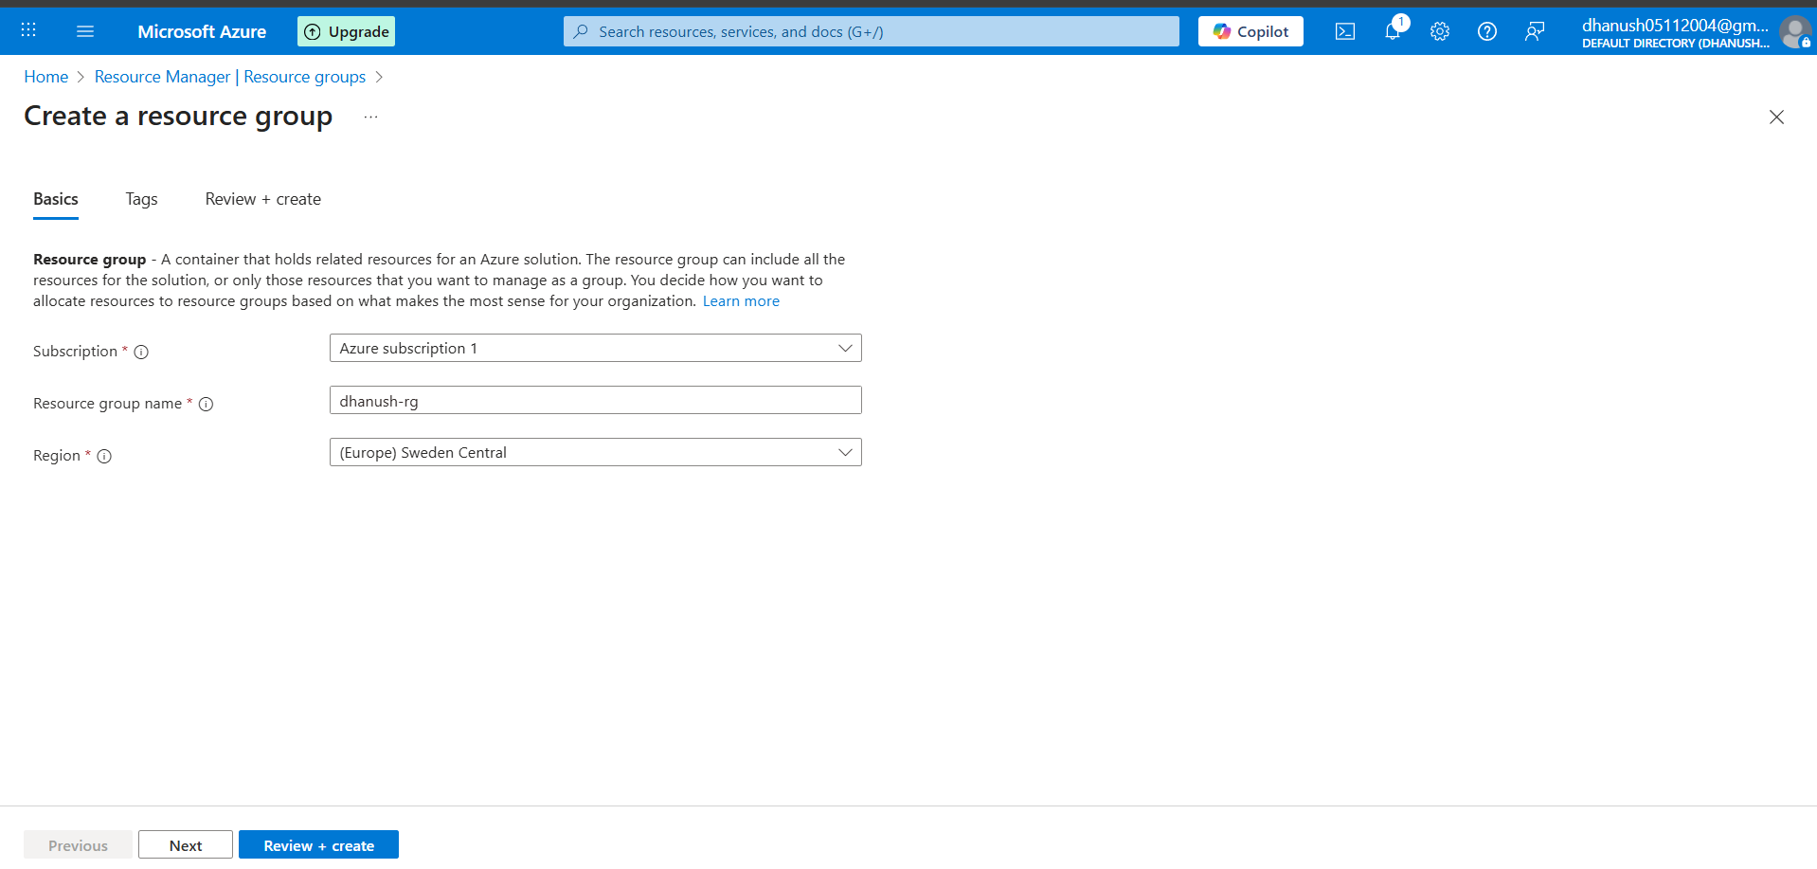

STEP 2: Create a Virtual Network
- Go to Virtual networks → + Create.
- Enter:
  - Name: <studentname-vnet>
  - RG: <studentname-rg>
  - Address space: 10.0.0.0/16
  - Subnet: Name <studentname-subnet>, 10.0.1.0/24
- Click Review + Create → Create.
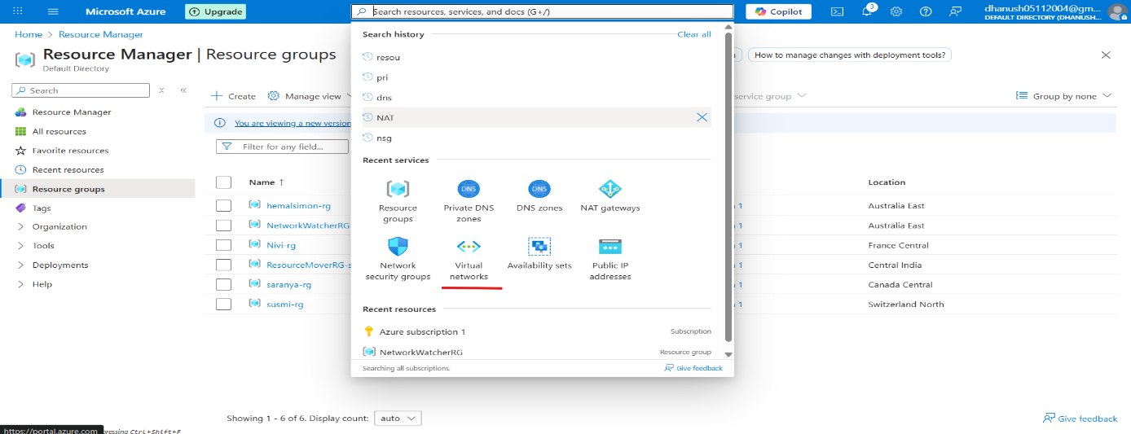
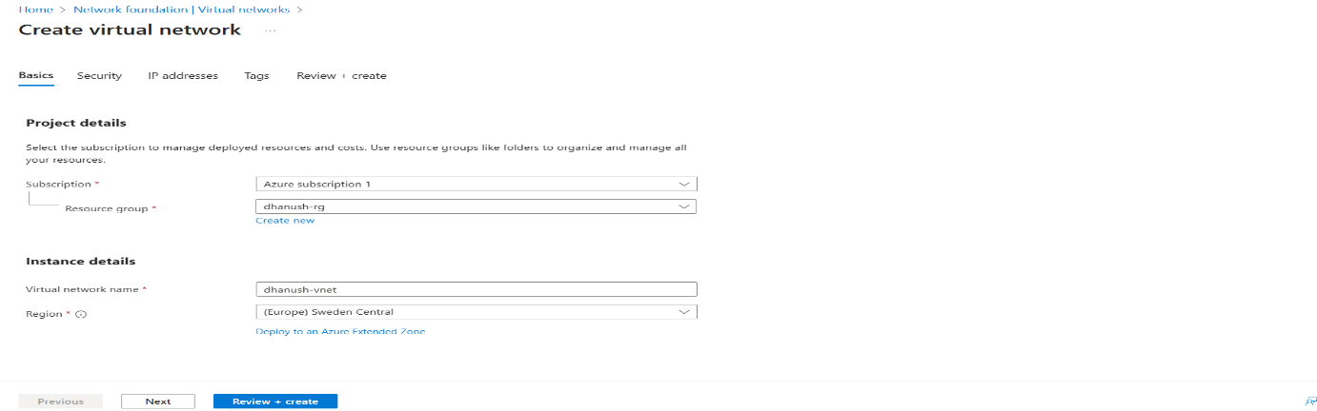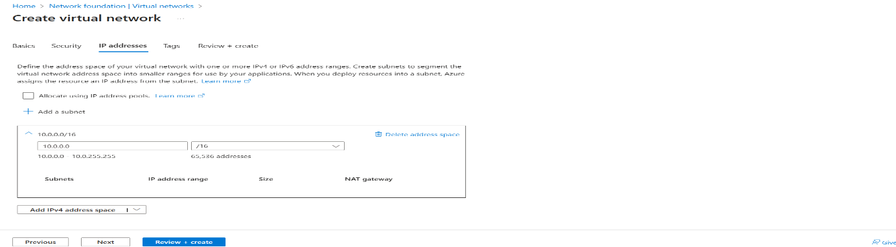
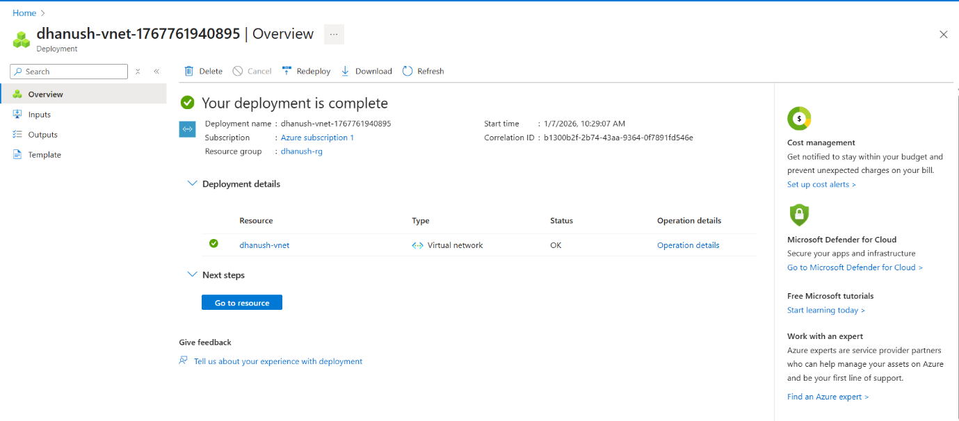
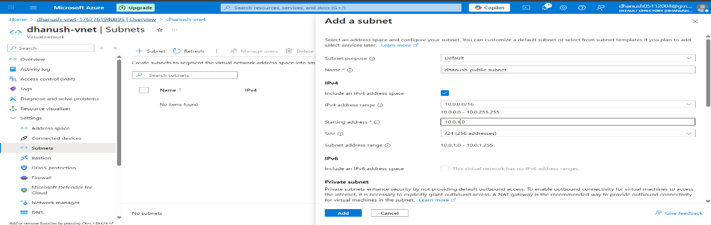

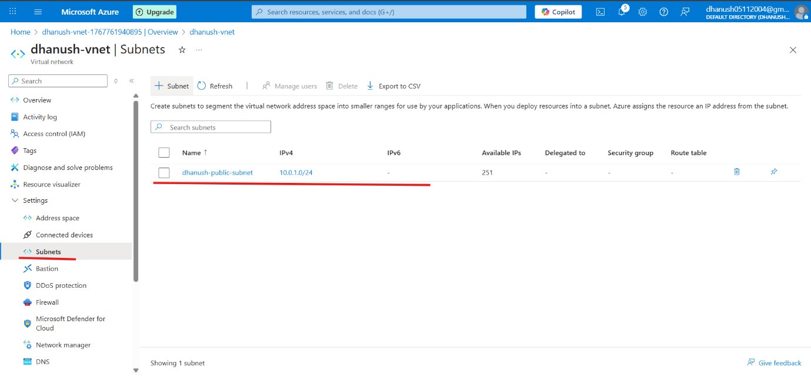
STEP 3: Create Two VMs
- Go to Virtual machines → + Create → Azure Virtual Machine.
  - VM1: <studentname-vm1>
  - VM2: <studentname-vm2>
  - Resource group: <studentname-rg>
  - Image: Ubuntu Server 22.04 LTS
  - Size: Standard_B1s (for lab)
  - Authentication: SSH or Password
  - Networking: Select /
  - Public IP: None (so only accessible via Load Balancer)
- Repeat for second VM.
VM1
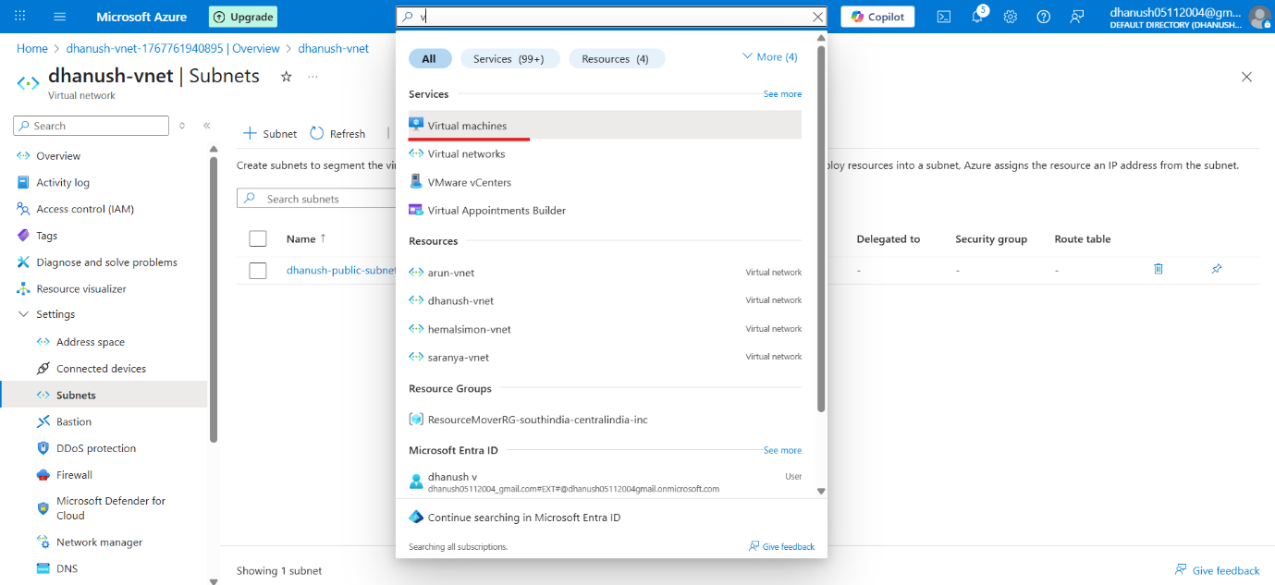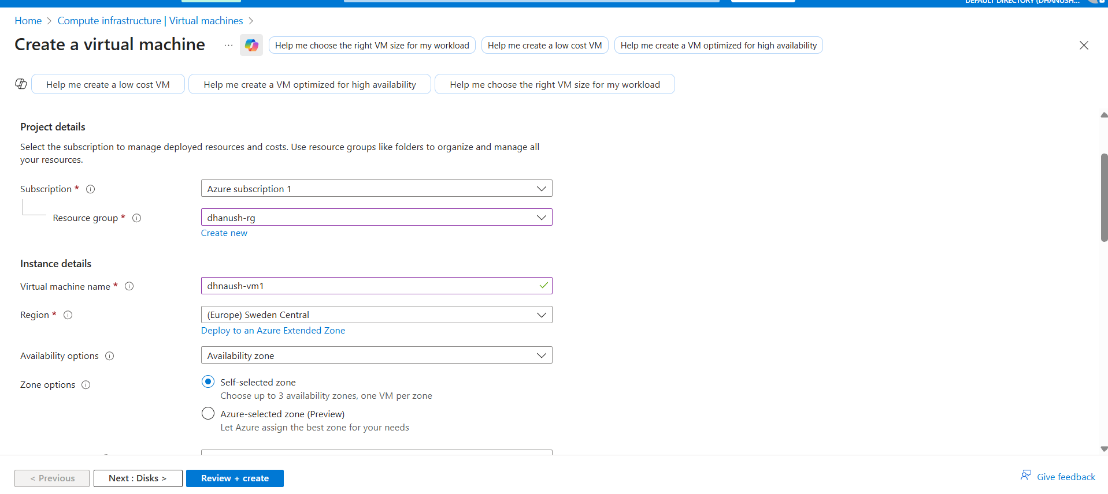
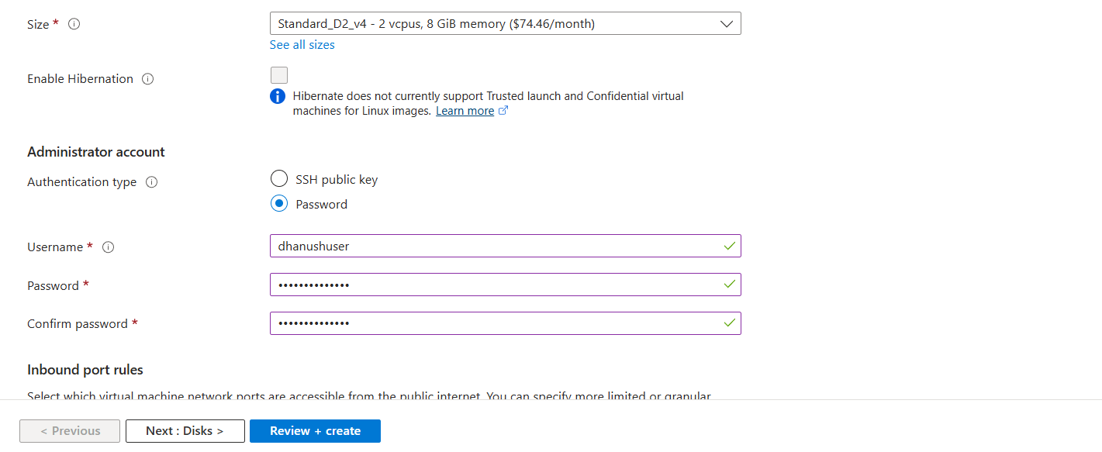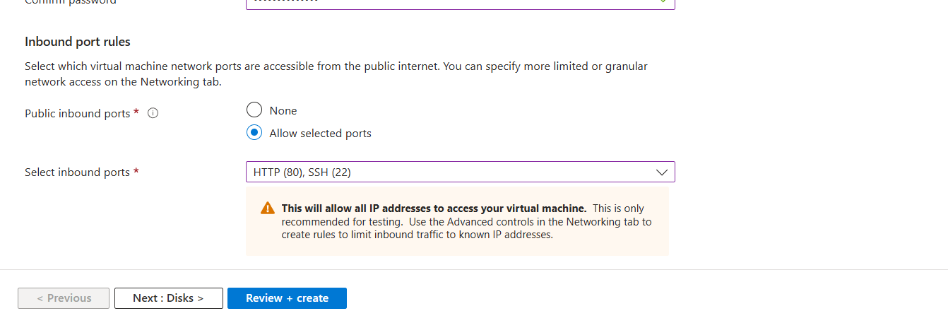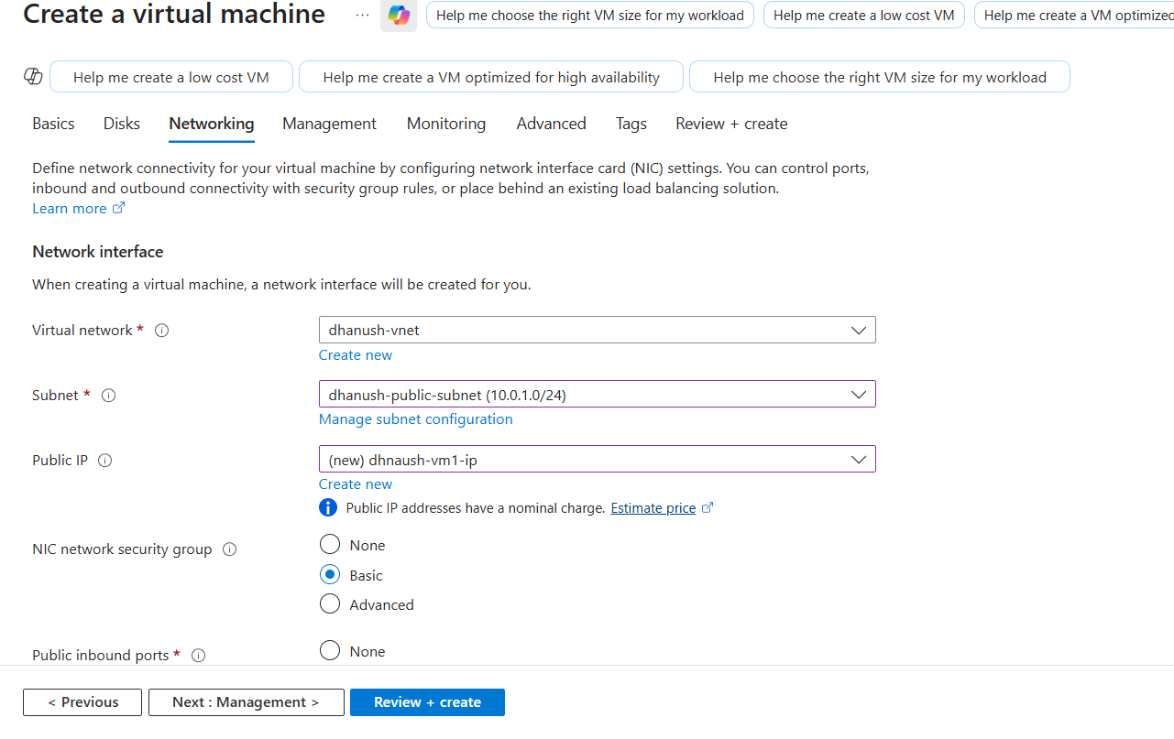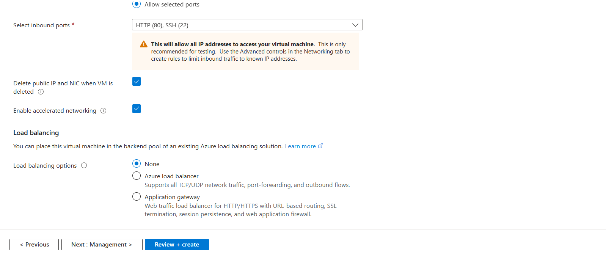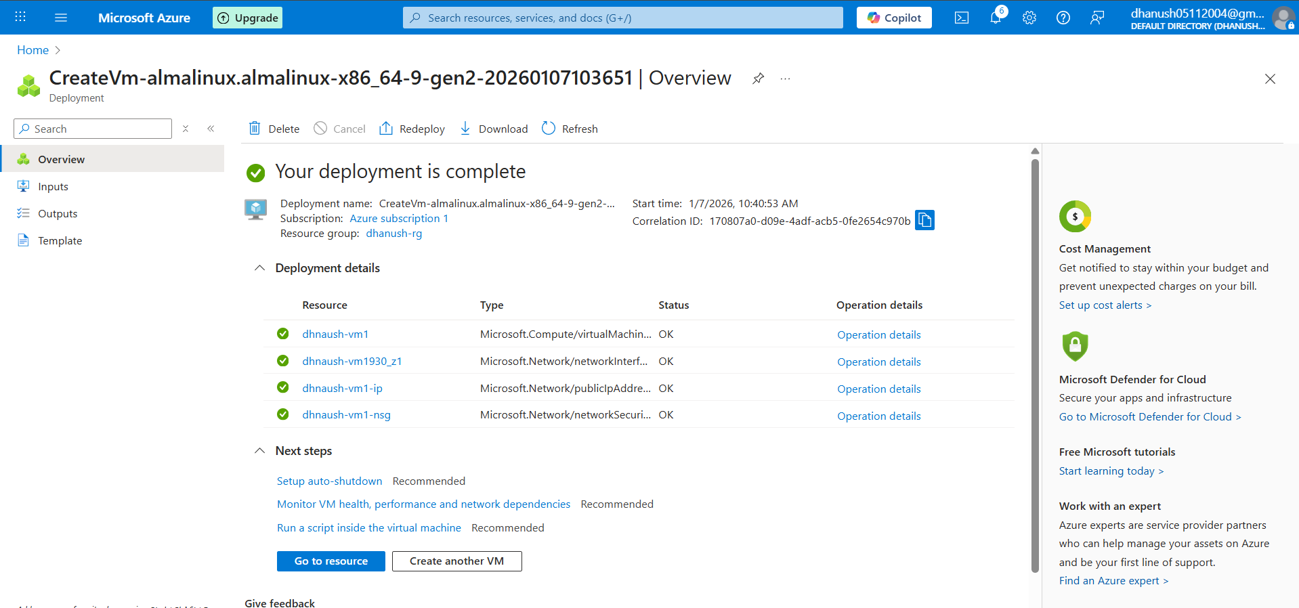
VM2
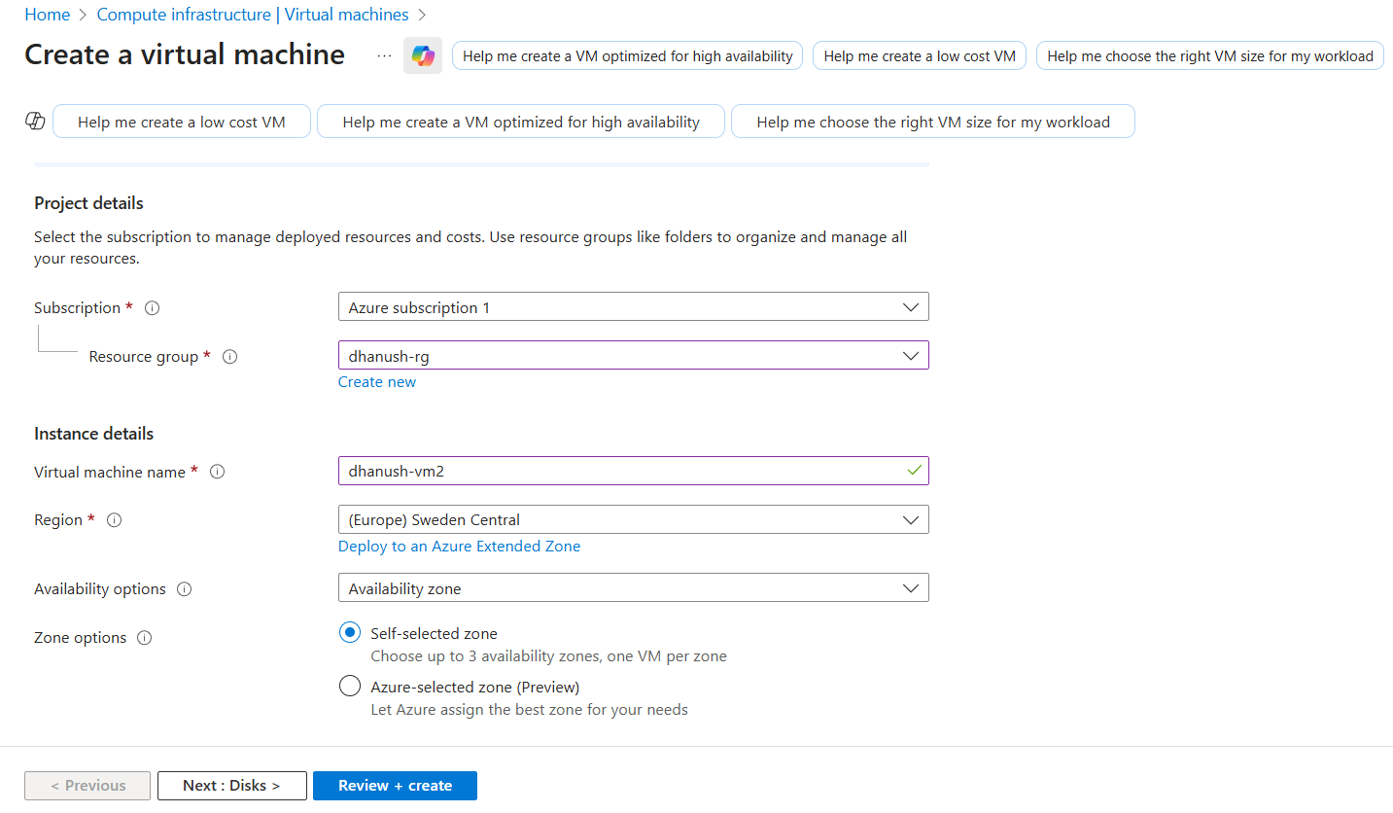
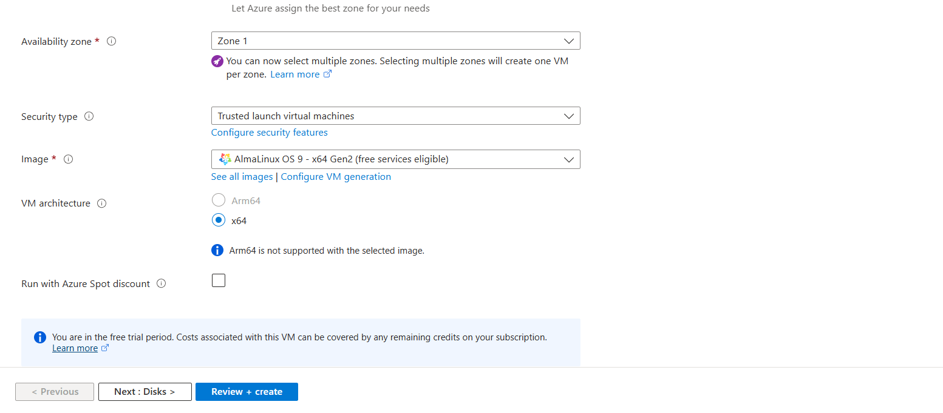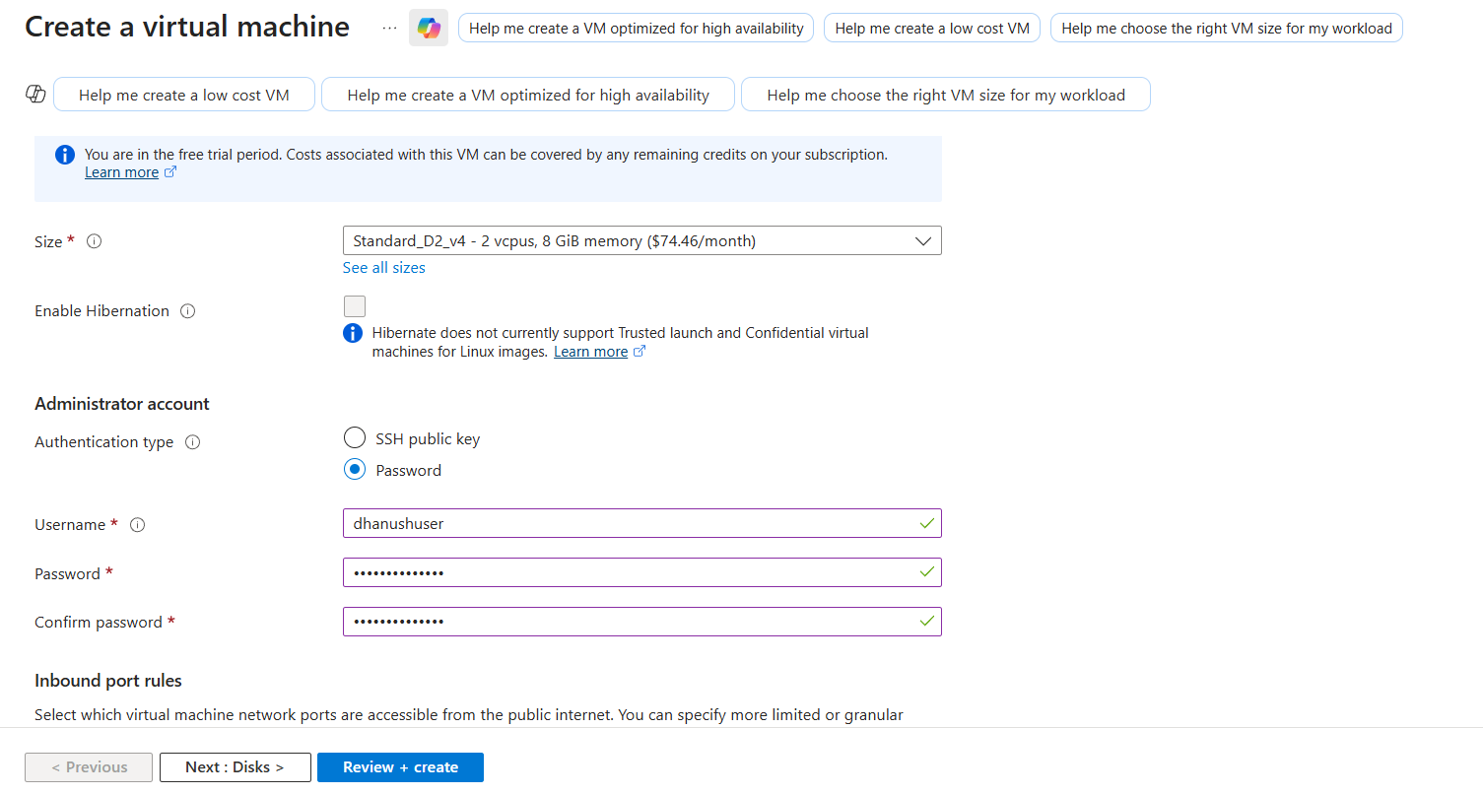
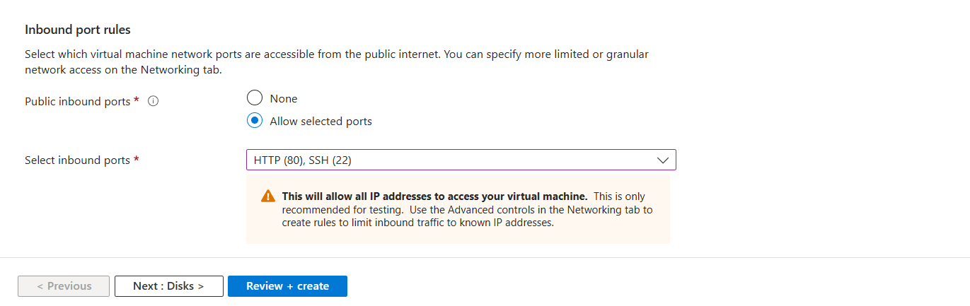

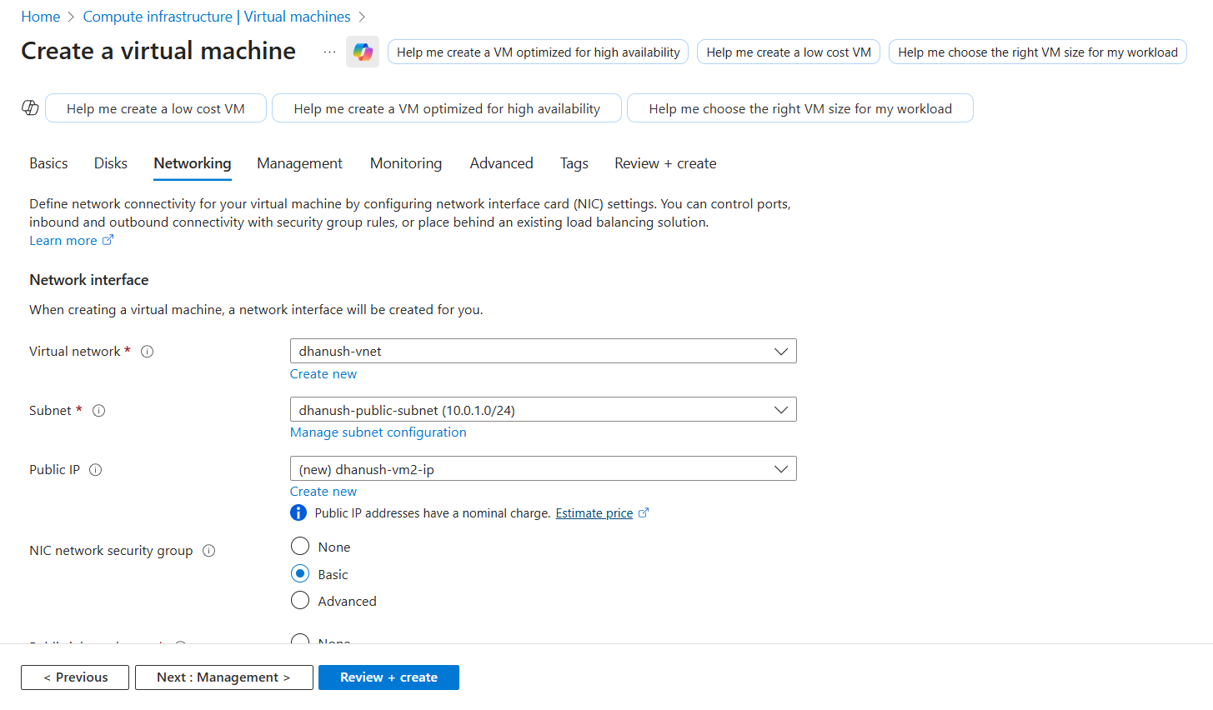
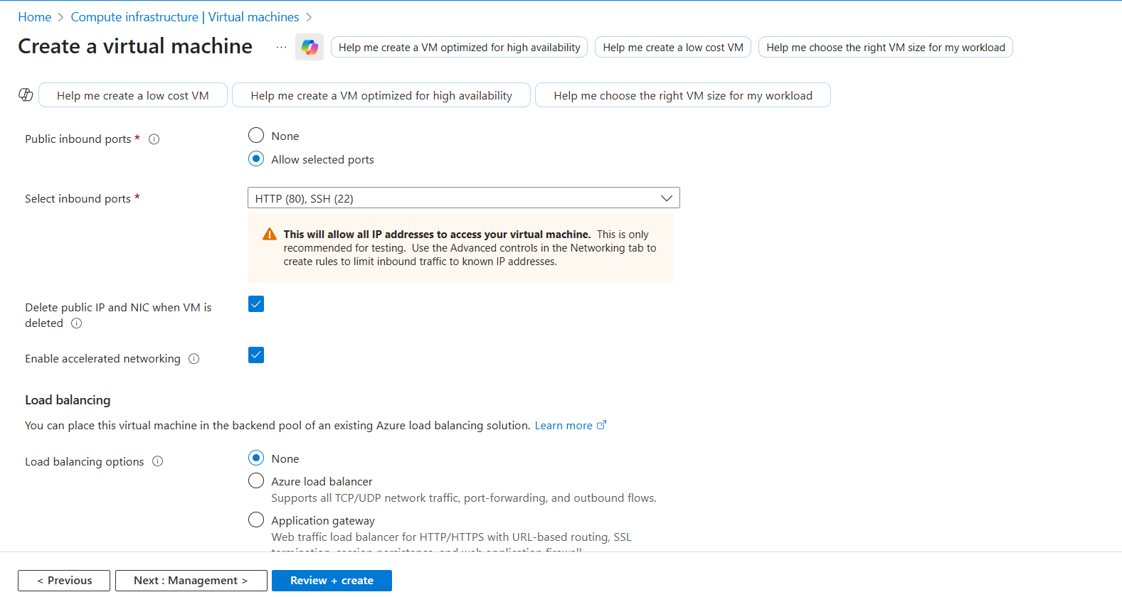
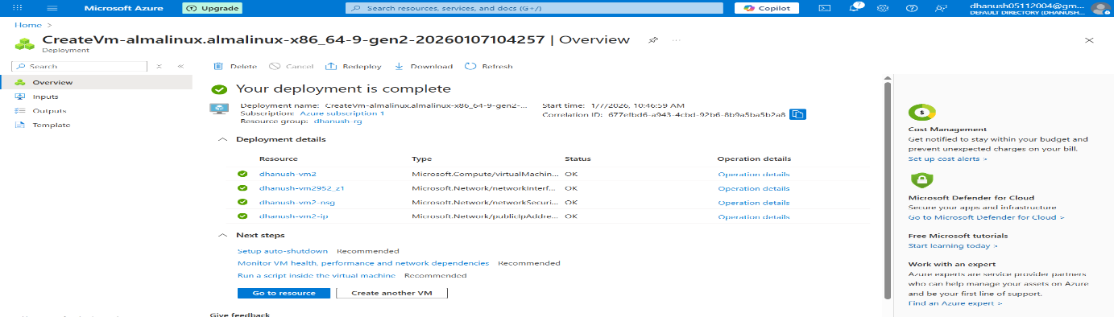

STEP 4 : connect the vm1 and vm2 in the cmd
Vm1
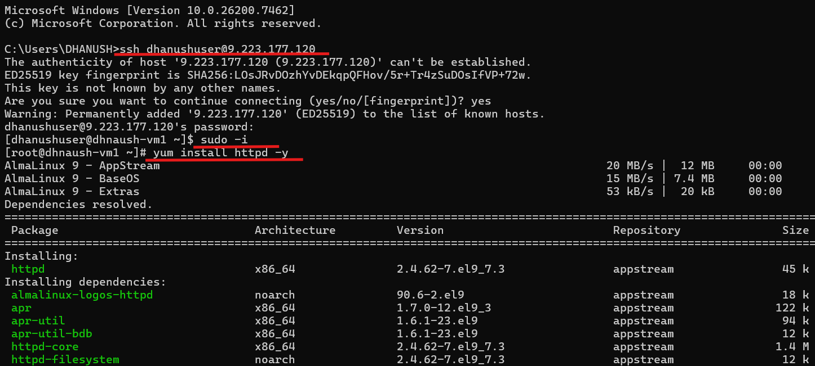
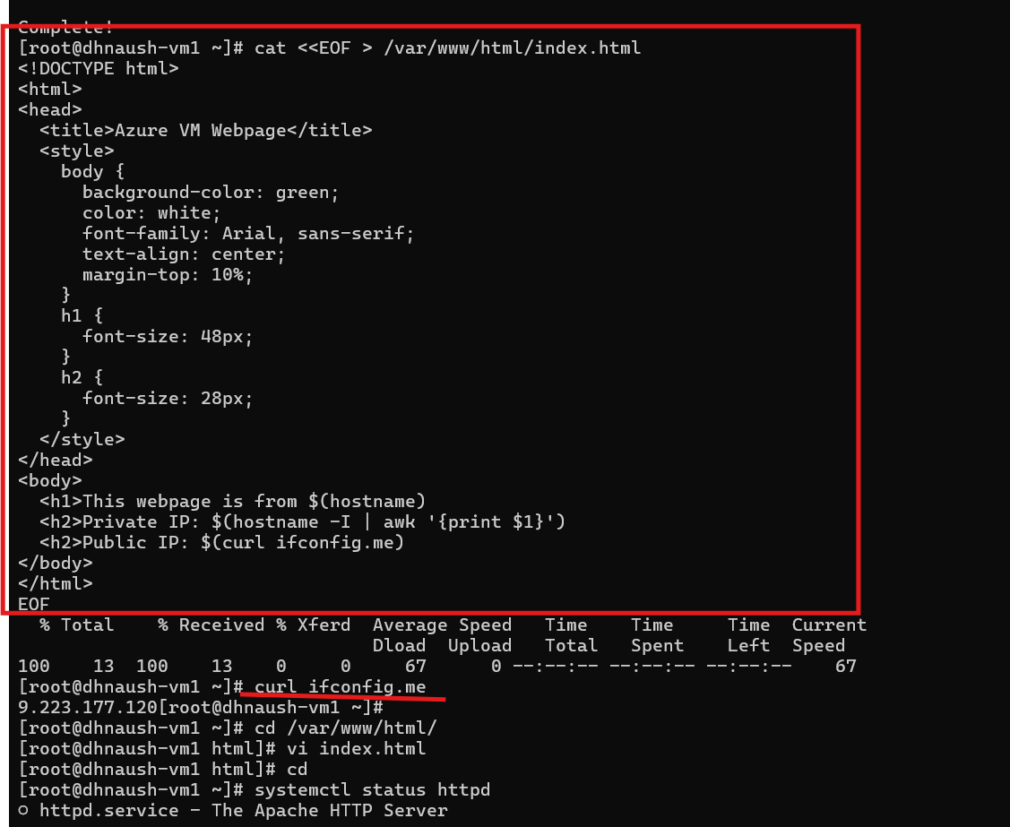
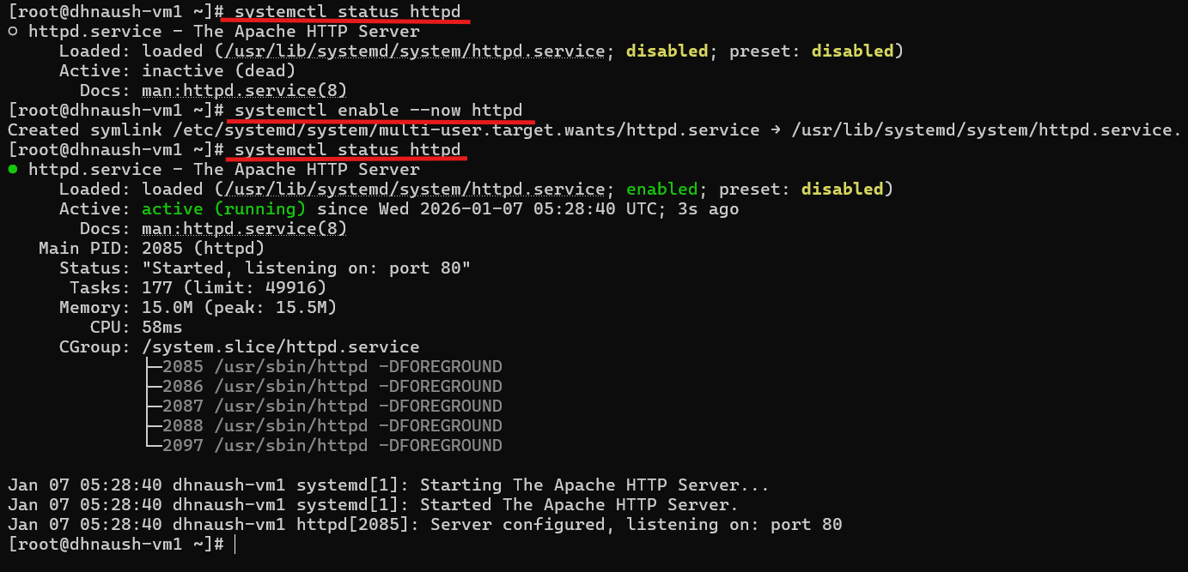
Output
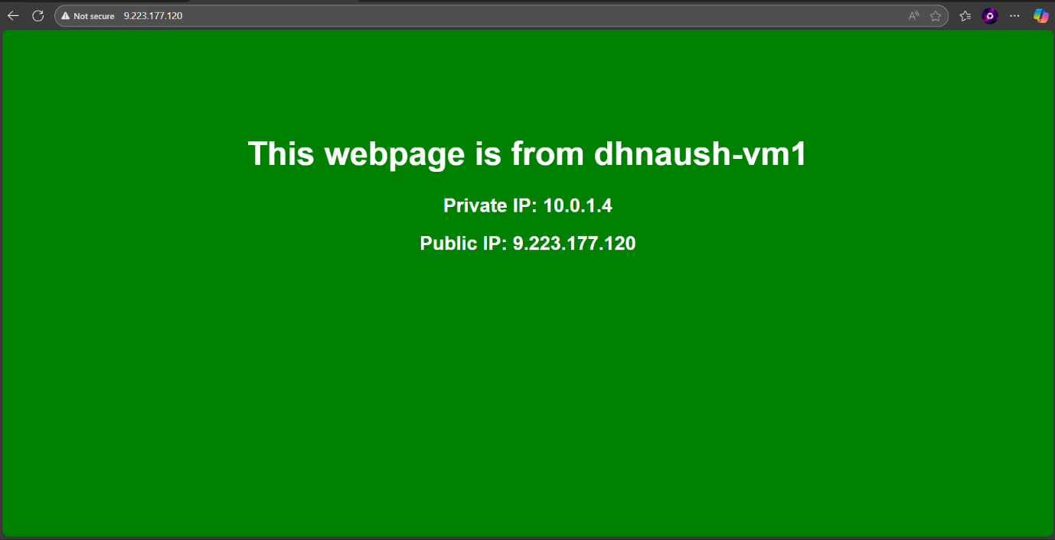
Vm2
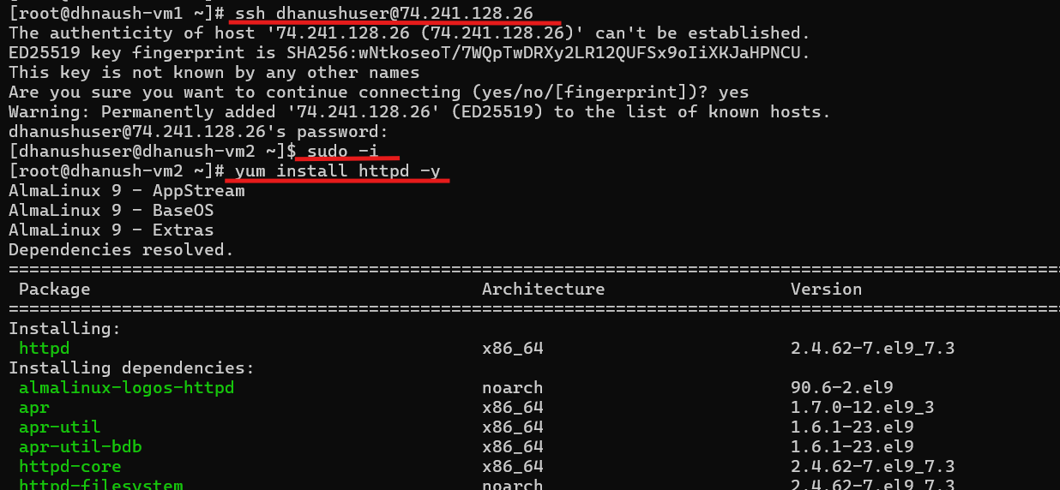
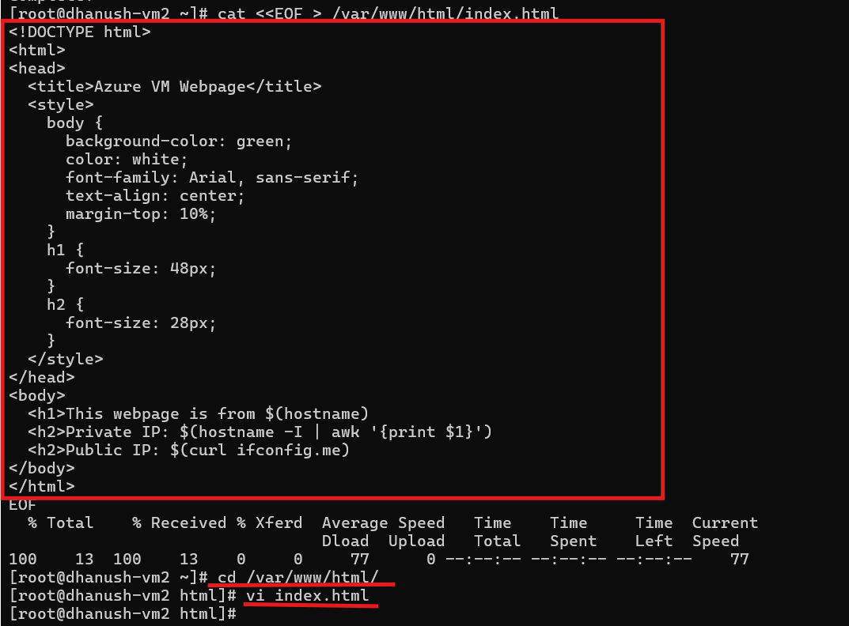
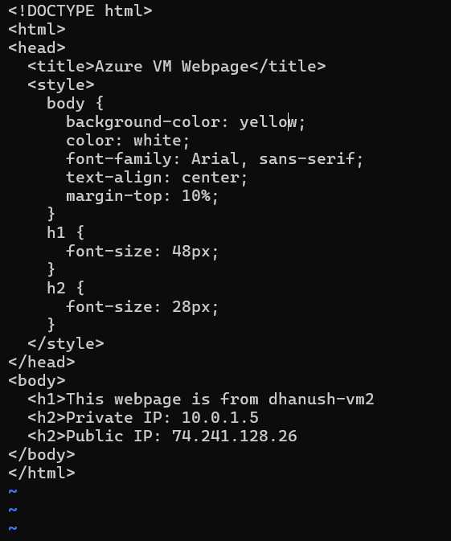
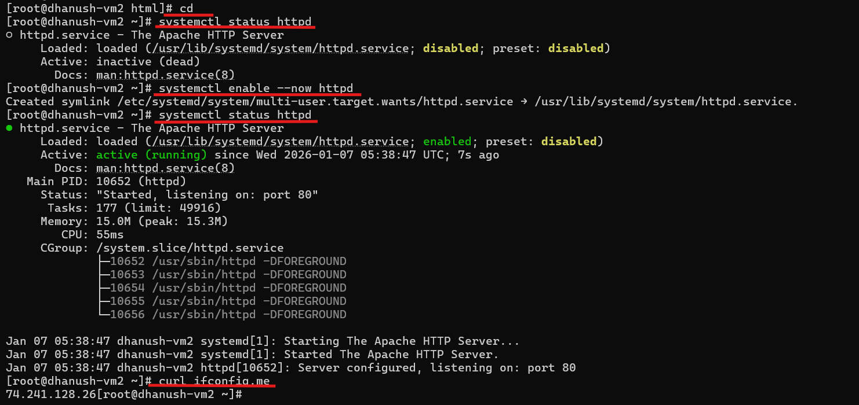

Output
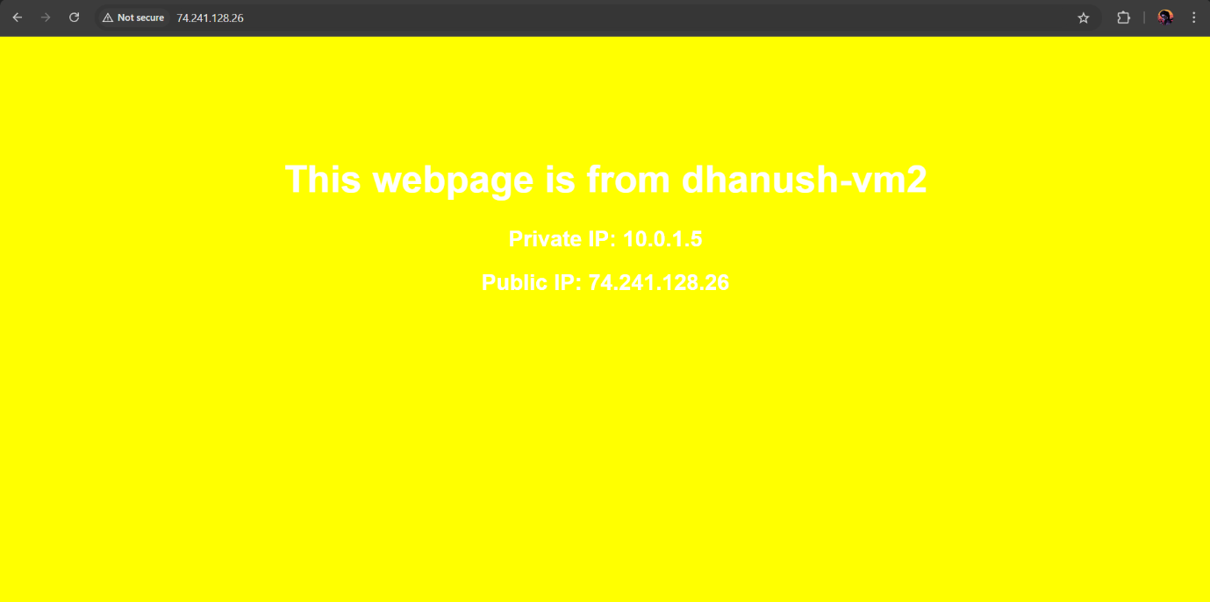
STEP 5 : Create the Load Balancer
- Go to Load balancers → + Create.
- Enter:
  - Name: <studentname-lb>
  - RG: <studentname-rg>
  - SKU: Standard
  - Type: Public
  - Public IP: Select <studentname-pip>
- Click Review + Create → Create.
STEP 6 : Frontend config ip
- Ipv4
- Type – ip address
STEP 7: Configure Backend Pool
- Open <studentname-lb> → Backend pools → + Add.
- Name: <studentname-bepool>
- Associate to VNet: <studentname-vnet>
- Leave No targets for now (we will add VMs later).
- Click Add.

STEP 8 :Configure Health Probe
- Go to Load balancer → Probes → + Add.
- Name: <studentname-hprobe>
- Protocol: TCP
- Port: 80
- Interval: 5 seconds
- Unhealthy threshold: 2
- Click Add.

STEP 9: Configure Load Balancing Rule
- Go to Load balancer → Load balancing rules → + Add.
- Name: <studentname-lbrule>
- Frontend IP: <studentname-frontend> (default frontend created)
- Backend pool: <studentname-bepool>
- Protocol: TCP
- Port: 80 → 80
- Probe: <studentname-hprobe>
- Click Add.
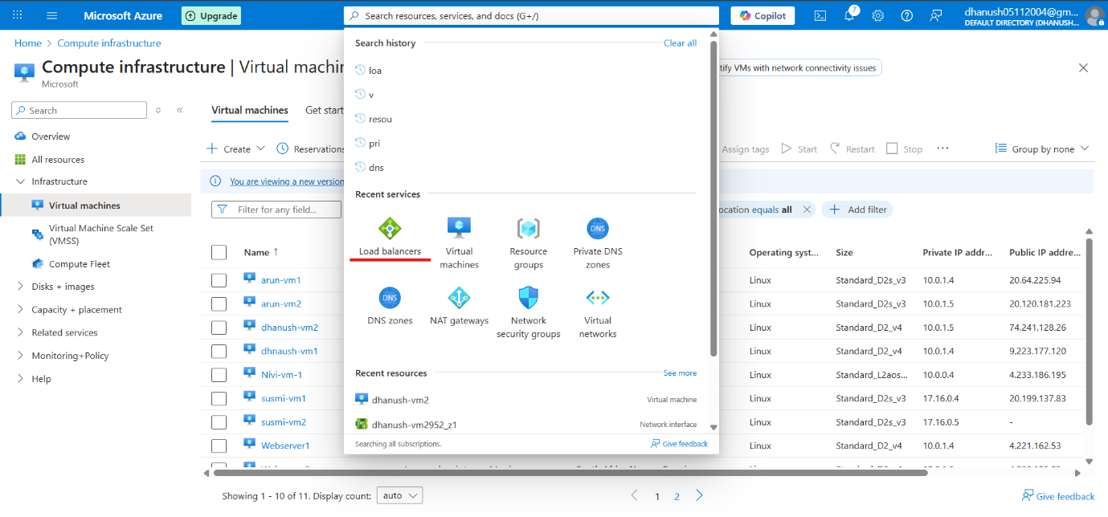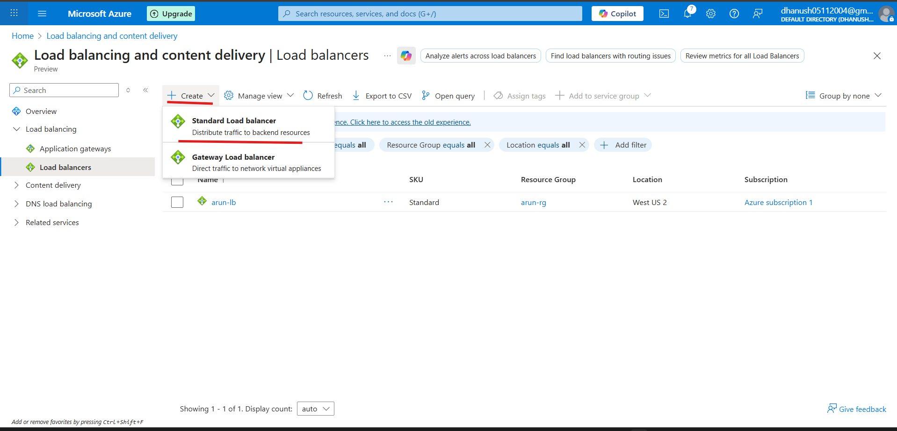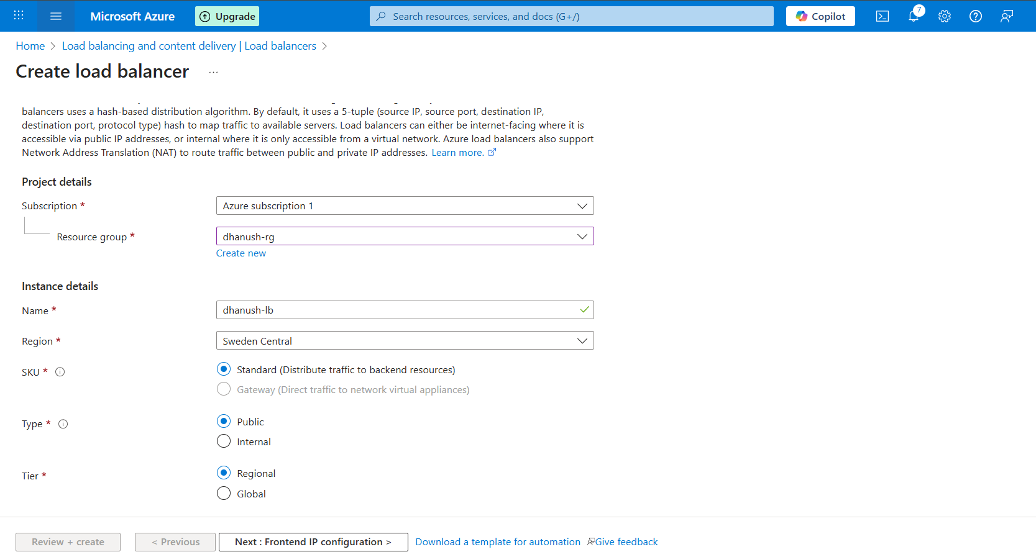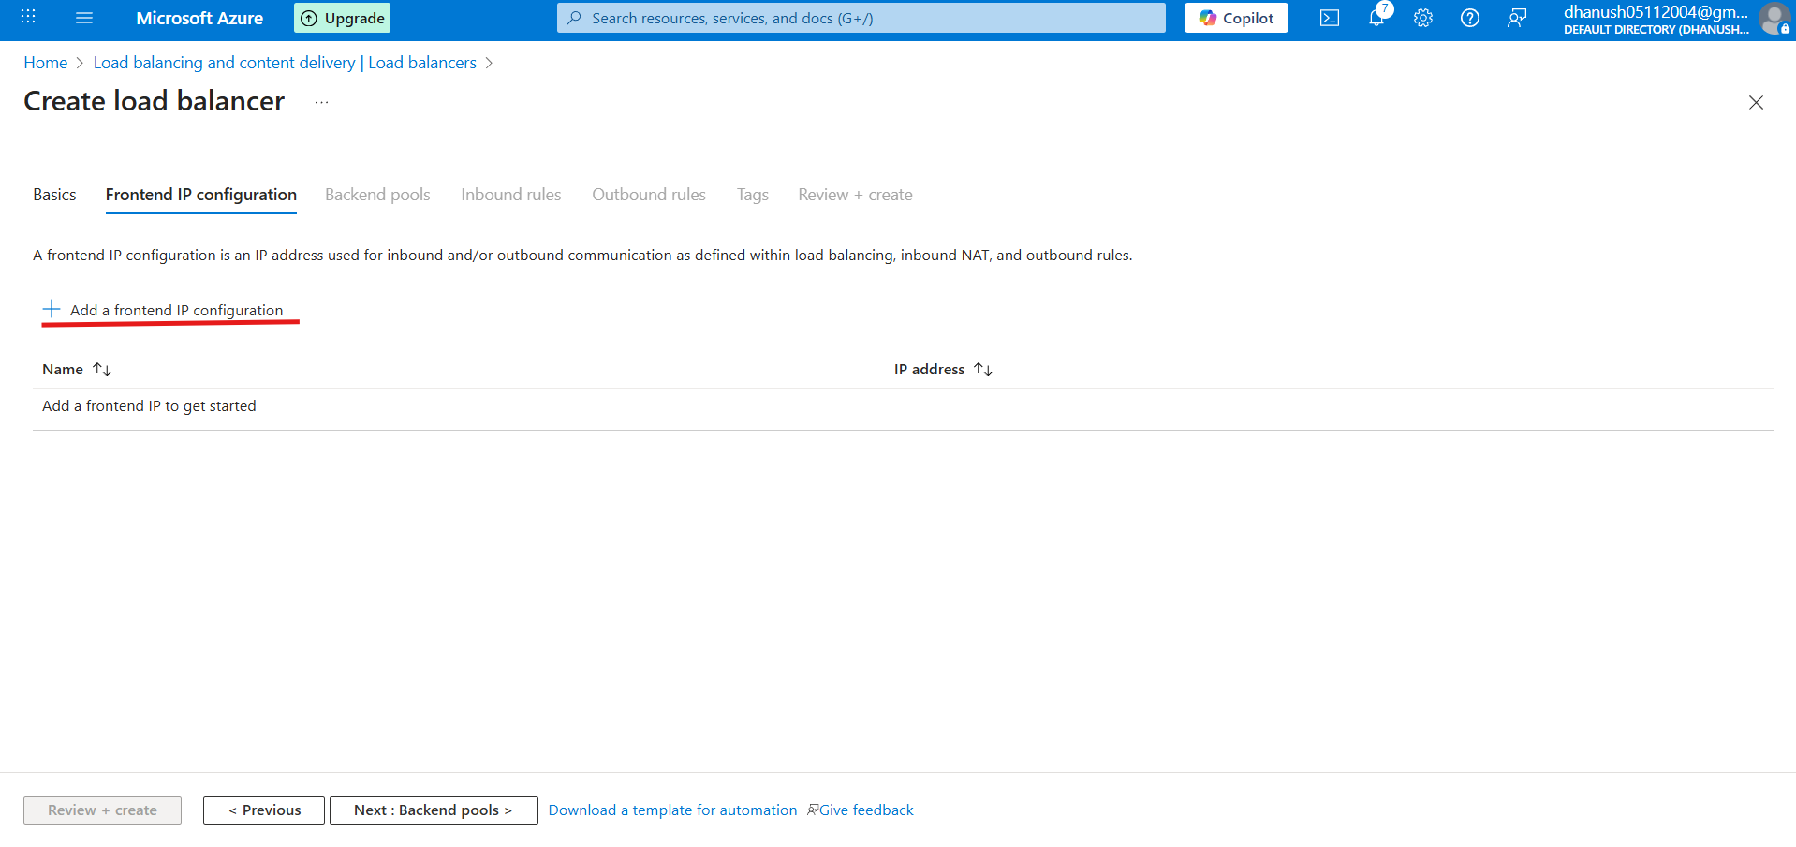
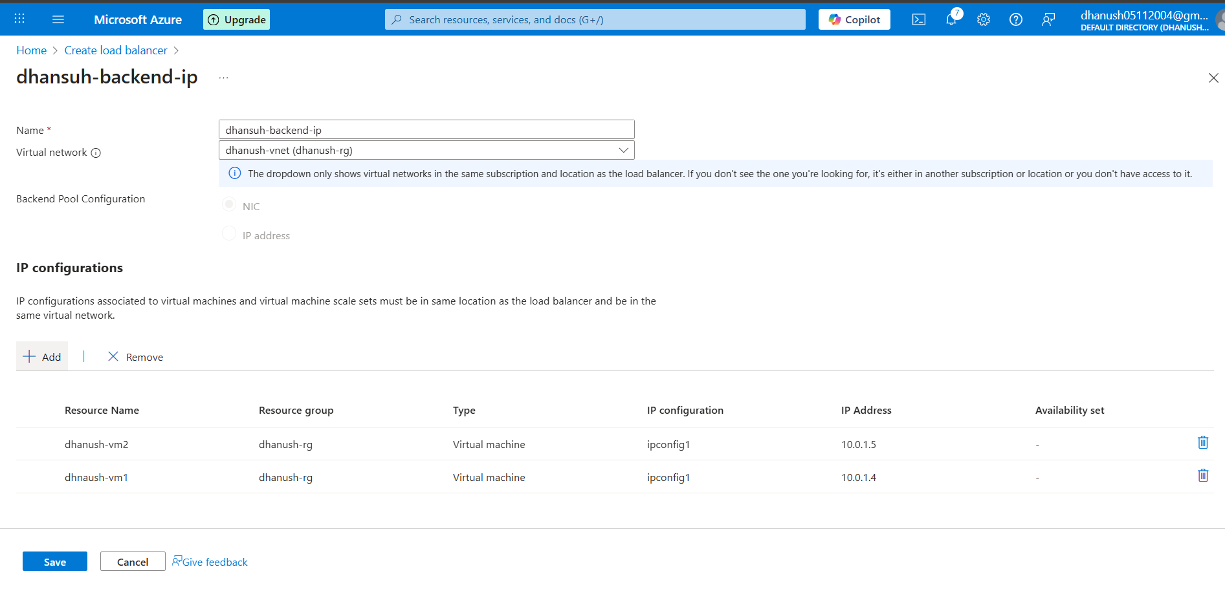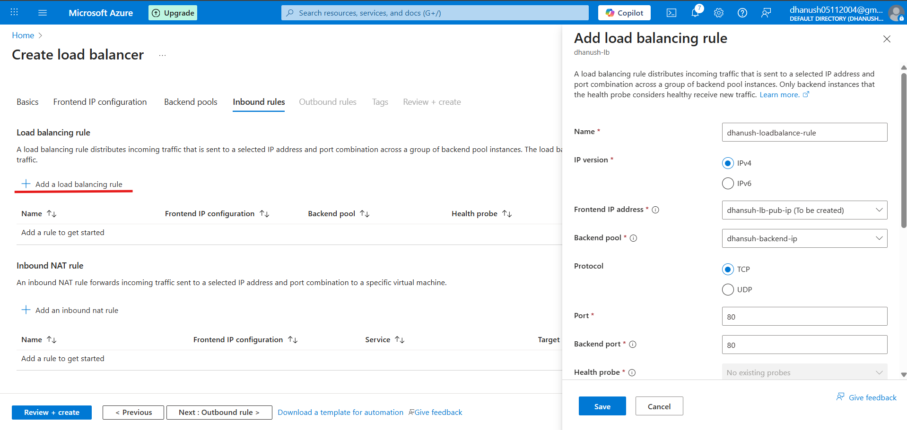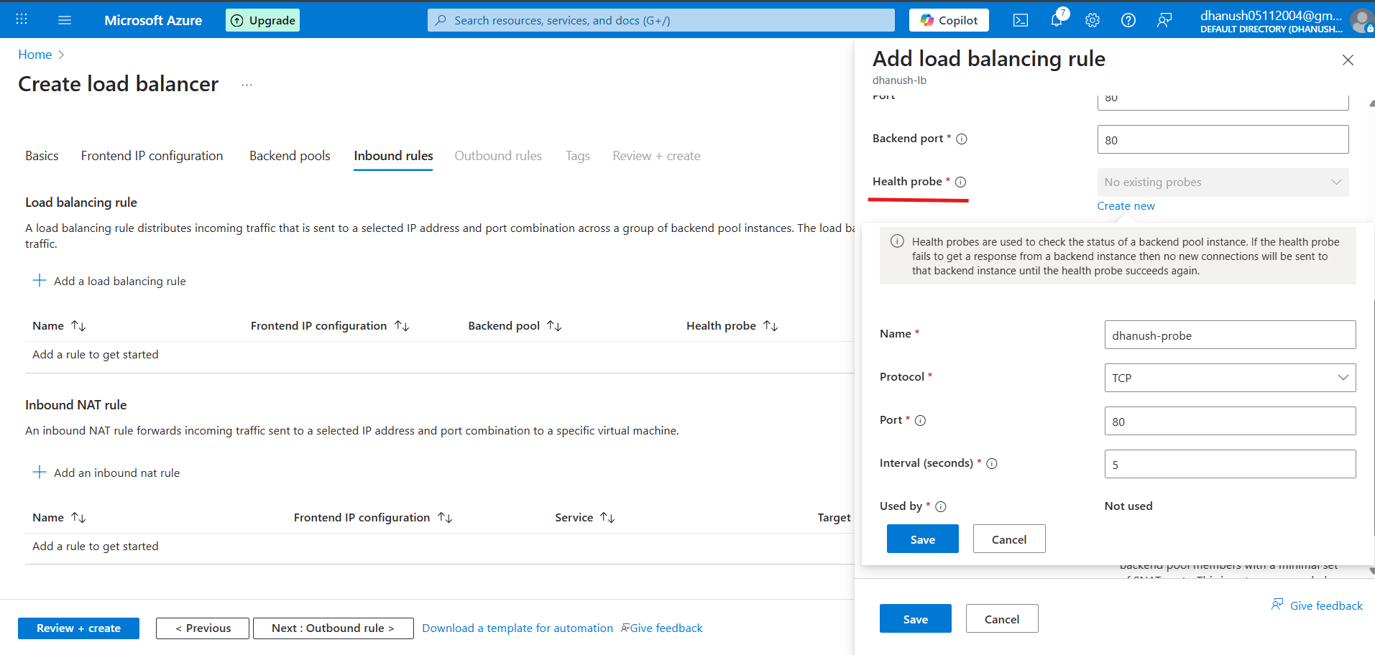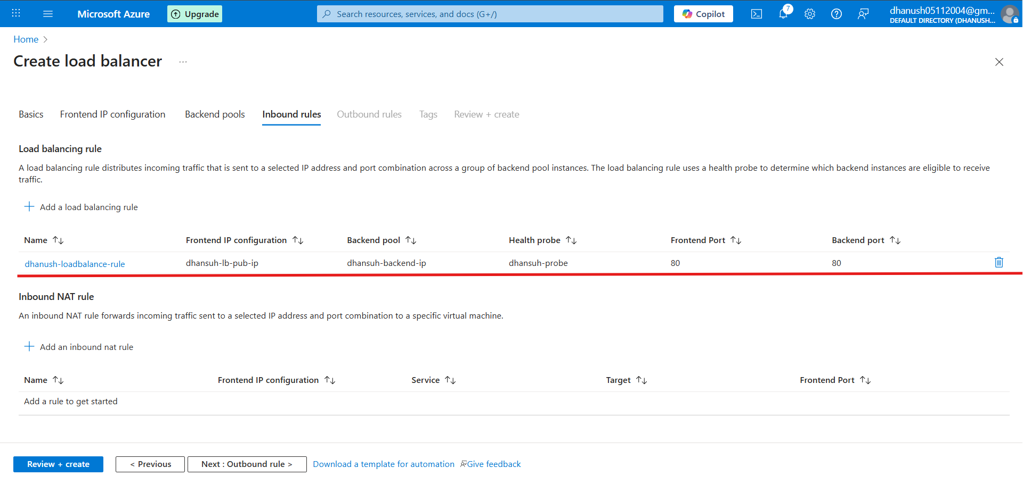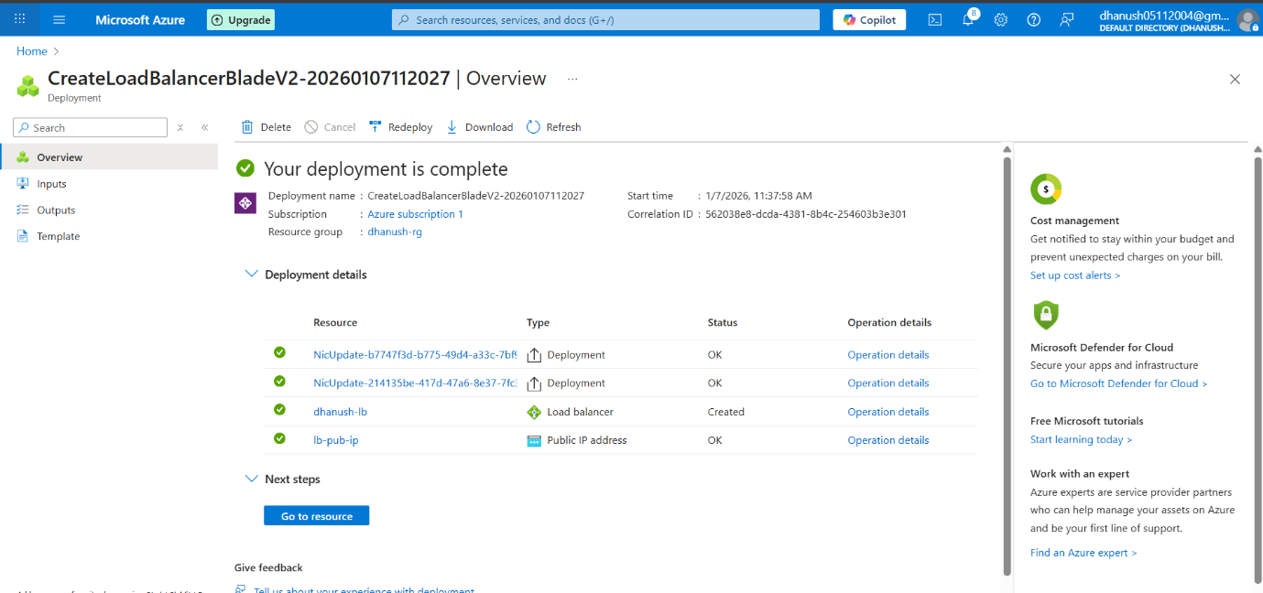
STEP 10: Test Load Balancer
- Go to Public IPs → <studentname-pip> → Copy IP Address.
- Open browser: http://<public-ip>
- Refresh a few times:
  - Response alternates between:
    - Hello from <studentname-vm1>
    - Hello from <studentname-vm2>

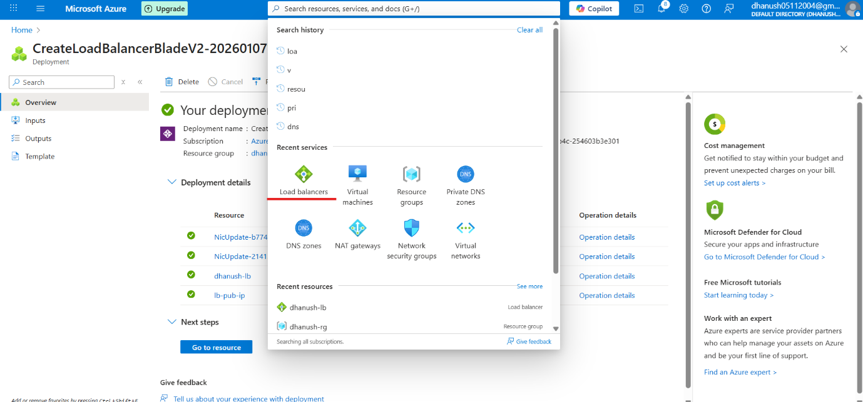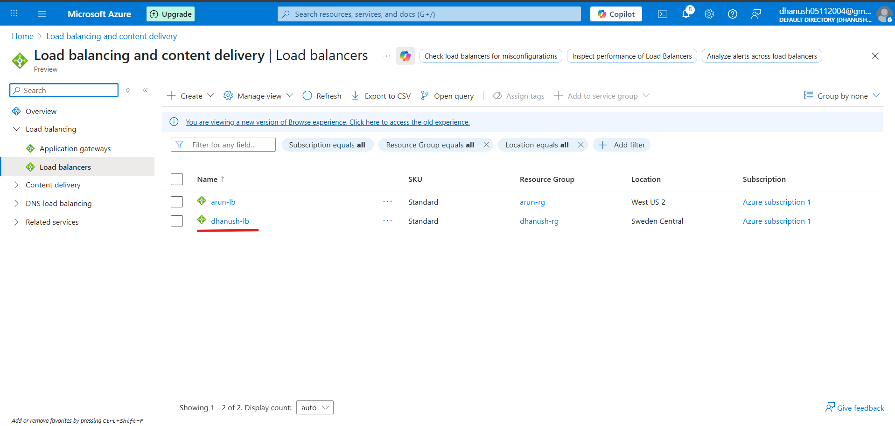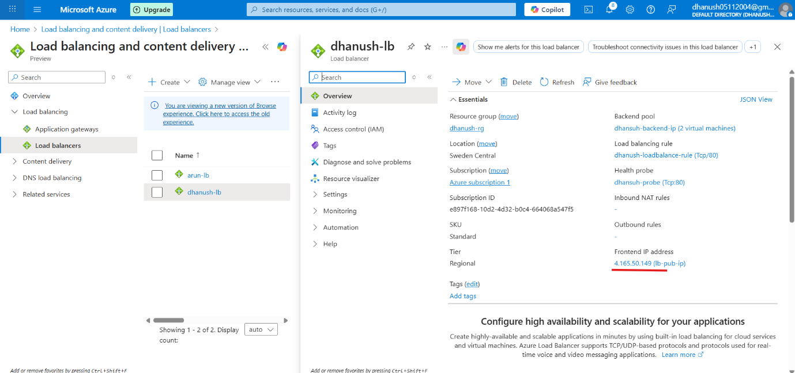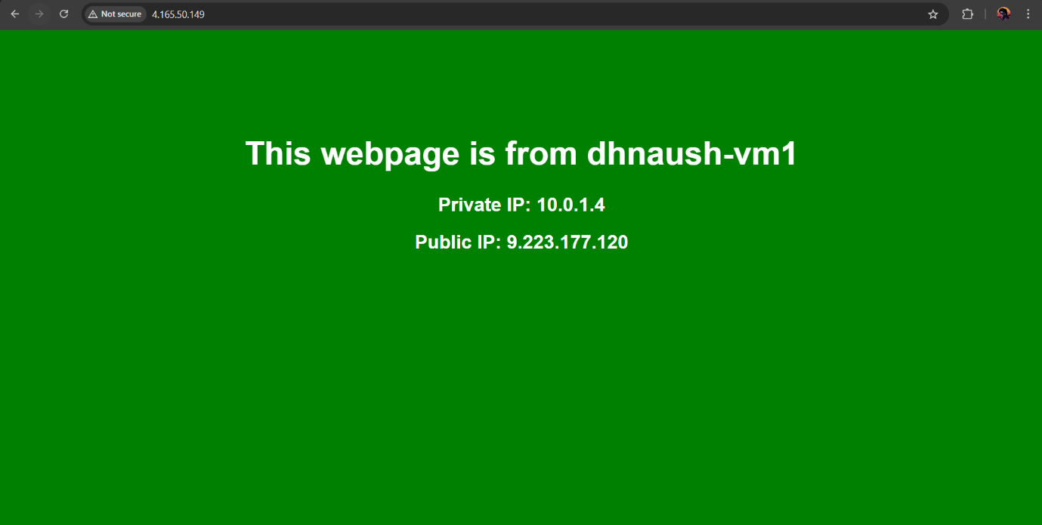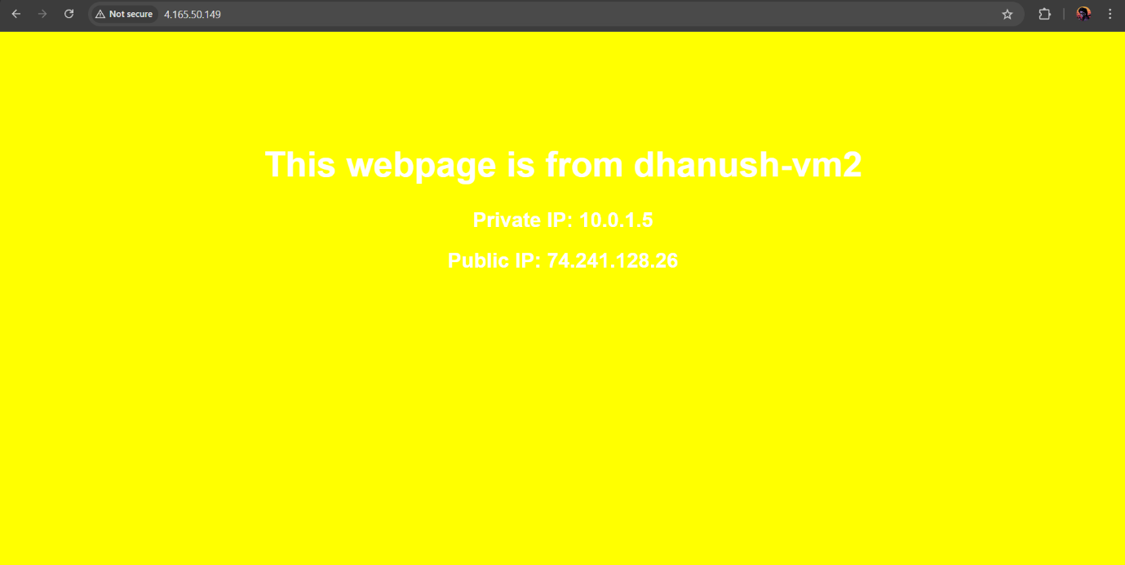
✅ End of Lab → You now have an Azure Standard Load Balancer distributing traffic between two Apache VMs.

To stop the vm1 (or) vm2 go to the cmd and
Using
- Systemctl stop httpd
For start
- Systemctl enable --now httpd
- Systemctl start httpd

